|  |  |
| --- | --- |
| WEST LONDON WASTE AUTHORITY |  |
| Report of the Projects Director and Strategic Development Lead | 24 March 2023 |
| **Food recycling projects Update** | |
| SUMMARY This report provides an update on the Authority’s Food Waste investment in Borough Business Cases, approved in September 2020.   * Individual Borough food waste project progress * Boroughs are delivering returns through food waste reduction and diversion * Delays have hindered some Boroughs projects and returns | |
|  | |
| **RECOMMENDATION(S)**   1. *The Authority is asked to note the information within this report.* | |

1. **Introduction -** The West London Waste Food Waste investment approved £3m of reserves in 2020, to fund investment in the Borough food waste services to increase food waste collection.
2. **Background** - There are multiple factors that impact on the amount of food being thrown away and which collection service it is put in. These include factors within the control of councils such as the number of households with a collection service, the availability of good quality information and equipment to use the service as well as external factors such as household income, food behaviours such as using leftovers rather than throwing them away and perception of services.

It is possible to measure the overall trends of waste generation as well as the following factors:

1. Separate food recycling collected – the quantity of food waste residents put in their food recycling service
2. Proportion of food in the residual – how much food waste residents put in their rubbish bins
3. Capture rate – how much of the total food that’s thrown away is collected in the food recycling service
4. Residual waste – the quantity of waste residents throw away

Each of these metrics have an impact on the value of a return on investment and therefore need to be considered together.

1. **Food projects updates**

In 2020 the boroughs submitted project business cases setting out how the funding would be used to increase separately collected food waste for recycling by removing it from the residual waste stream. Each project included key actions to monitor project progress against. These were assessed against performance criteria to calculate potential return on investment (ROI) based on assumptions about the weight of food waste available in the collection system. Since 2020 there have been external factors and internal changes in many boroughs which have resulted in some changes of project scope or timetable. This section outlines the status for each individual food recycling project up to the end of December 2022 and is based on information provided by the Boroughs.

**Brent**

|  |  |  |
| --- | --- | --- |
| **Project Summary** | Brent have been in the expiry and reprocurement phase of their collections contract and as such have delayed their food project to align with the commencement of the new service to ensure the long term viability of the project with the successful contractor. The project is to provide an additional 56,000 flats with equipment and consumables to increase the utilisation of the collection service. | |
| **Targets** | | **Results** |
| Provide a kerbside food recycling service to an additional 56,000 flats | | Brent have started the procurement for consumables and containers but currently no additional properties have been added to the service |
| **Project spend** | | £0 |

**Ealing**

|  |  |  |
| --- | --- | --- |
| **Project Summary** | * Introduce service to 20,000 flats that currently do not receive a food waste collection service. * Supply of new equipment and targeted communications to 25,000 homes in 11 current collection rounds to improve volumes collected i.e. efficiency. This action was revised to targeting non-participating households on all collection rounds with caddies, rolls and leaflets. | |
| **Targets** | | **Results** |
| Provide a kerbside food recycling service to an additional 20,000 flats | | 10,207 flats added to the service |
| Targeting non-participating households on all collection rounds with caddies, rolls and leaflets. | | 3,853 properties were identified and targeted (complete) |
| **Project spend** | | £340,488 |

**Harrow**

|  |  |  |
| --- | --- | --- |
| **Project Summary** | Originally the business case was to introduce food waste services to 1500 businesses and 800 flats above shops. This has been revised to be 250 businesses and schools, 5500 flats in communal properties and 1000 flats above shops. | |
| **Targets** | | **Results** |
| Provide a kerbside food recycling service to 250 businesses and schools | | 40 new businesses are receiving the service |
| Provide food recycling service to 5500 communal properties | | 3548 flats in communal properties have been added |
| Provide food recycling service to 1000 flats above shops | | 588 flats above shops have been provided with a service |
| **Project spend** | | £409,195 |

**Hillingdon**

|  |  |  |
| --- | --- | --- |
| **Project Summary** | Introduce separate kerbside food service to homes either with no service or currently receiving a mixed organic service. | |
| **Targets** | | **Results** |
| Introduce a separate food waste service to all properties that previously received a mixed organics service | | The service was introduced in May 2021, since then 4944 tonnes of food waste have been collected. |
| Procure five top loader vehicles to facilitate separate food and green waste collections | | Complete |
| Provide kerbside collection service to 30,000 new subscribers | | 41,896 (140% complete) |
| Project spend | | £500,000 |

In addition, Hillingdon are taking part in a trial to track usage of food recycling collections in 5 schools following communications and engagement with the schools. A trial food recycling service has been introduced to 159 flats. The plan is to expand this service to as many flats as possible in Hillingdon Housing estates throughout 2023/24.

**Hounslow**

|  |  |  |
| --- | --- | --- |
| **Project Summary** | * Introduce service to 24,500 flats that currently do not receive a food recycling collection service. * Supply of new equipment and targeted communications to 10,500 homes in 5 current collection rounds to improve volumes collected i.e. efficiency. | |
| **Targets** | | **Results** |
| Introduce service to 24,500 flats | | 24,500 flats are now receiving the service |
| Purchase 2 vehicles to collect the bins as part of the bin exchange and cleaning service | | The vehicles have been procured but have yet to be delivered due to a national shortage of larger vehicles and long lead times. The service began in April 2022 using hire vehicles. |
| Improved behaviours towards food waste recycling in 5 current collection rounds to increase volumes collected | | * Limited participation monitoring targeted 440 non-participating kerbside properties in September 2021 and three further wards in February 2022. * A targeted communication campaign was carried out in the Brentford Dock estate to increase the amount of food collected to 1kg/hh/wk, the impact was monitored by bin sensors. |
| **Project spend** | | £500,000 |

**Richmond**

|  |  |  |
| --- | --- | --- |
| **Project Summary** | Richmond have seen a change in contractor at the commencement of the project. The mobilisation of the new service and contractor has led to a delay in the expansion of the service and therefore the food project.   * Provide 17,000 flats with equipment and consumables to increase utilisation of the collection service * Introduce a commercial waste collection service to 540 new commercial customers * Identify non-participating households on the 5 lowest performing rounds and target communications and collection material such as caddy at these households | |
| **Targets** | | **Results** |
| Introduce service to 17,000 flats | | 3500 flats have been added to the service |
| 2540 businesses | | Currently on hold |
| Target non-participating households | | Currently on hold |
| **Project spend** | | £103,167 |

**West London Waste Authority**

To support the progress of these projects WLWA has:

* Procured and installed a bin wash system at Transport Avenue, this facility can be used by multiple boroughs.
* Provided fleet routing and efficiency services for integration of new properties on rounds and new services.
* Trialled Smart Cities technologies to measure fill and collection rates to generate smart routing for rounds with bin sensors.
* Provided communications support and resources for food waste services.
* New transfer operation for food waste at Victoria Road transfer station.

1. **Financial Implications**

As detailed in the background section above, it’s not possible to use one measure to capture the full financial implications of food waste being thrown away. Each of the measures described would independently deliver savings on disposal/reprocessing costs.

The measures used have been used to measure variance from a baseline and therefore cannot be used an measure of absolute performance of the service across Boroughs. All of the Boroughs started the project and therefore the baseline in different positions and continue to operate different systems from frequency to containerisation of collections. An example would be Harrow, on the tonnage and proportion of food in the residual their performance has declined however as depicted in the capture graphs they are still our top performing Borough at 30% of food waste captured.

The importance of interpolating the data between the metrics and the Boroughs starting point for the project is essential to establish an understanding of waste reduction, service maturity and performance.

**Tonnage of separate food recycling collected through borough services**

**Food waste trend from year-on-year change analysis**

The total tonnage of food separately collected for recycling has steadily increased year on year as shown on the graph below, until the Q4 2022. The inclusion of the Hillingdon separately collected material has provided a significant proportion of this growth.

Figure 1 – Food Waste tonnes with trendline

**Change in food collection since 2020**

Table 1 below shows how the collected weight of food has changed since a pre-pandemic baseline year, (the baseline is the average of 2018-19 and 2019-20 as having an average of 2 years reduces the effects of one-off events). The total to date tonnage increase since the baseline years is c.7000tonnes. The savings are based on this tonnage moving from the residual waste stream to the food waste service.

|  |  |  |
| --- | --- | --- |
| Table 1:  Additional food waste tonnage collected in the food recycling services up to December 2022 versus baseline figures ending in April 2020 | | |
| Borough | Tonnes | Savings (+ve)/growth (-ve) in residual waste costs as a result of food being separated |
| Brent | 178 | £20,238 |
| Ealing | 919 | £104,783 |
| Harrow | -1001 | -£114,128 |
| Hillingdon | 5562 | £634,098 |
| Hounslow | 1646 | £187,593 |
| Richmond | -144 | -£16,432 |
| **WLWA total** | **7159** | **£816,151** |

**Proportion of food in the residual waste**

The absolute volume of food waste captured for recycling only covers a proportion of the full food waste system. Food waste generated in households across west London predominantly flows through two routes 1) the food recycling service and 2) the rubbish bin, when households are not participating in food service provided or do not have access to that service.

Every 15 months a waste composition analysis is undertaken to understand the make up of the residual waste stream. Previous waste composition work has indicated the proportion of food waste in the residual stream has dropped from c.41% in 2019/20 to c.31% in 2021/22 then increased to 34% in 2022/23.

**Capture of food**

Using the tonnage data from food recycling services and the waste composition analysis for each of the last 3 years the capture rate for food being thrown away (whether placed in rubbish bins or in the food recycling services) can be measured as a snapshot in time. The graphs below show the total amount of food being thrown away is reducing gradually year on year and the proportion of it being placed in the food recycling service is increasing.

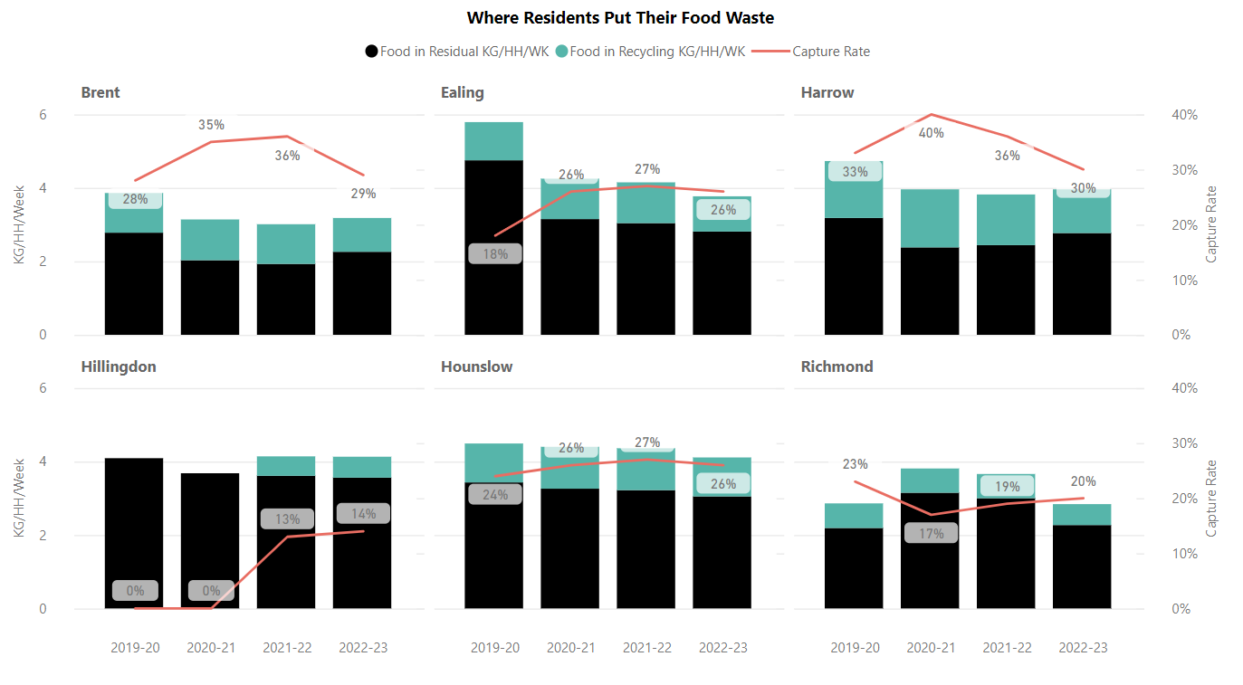

This supports the increase in participation through the expansion of the services by Boroughs (increasing capture rate) and the waste reduction theory for the service (total kg/household/week reducing through time).

Table 2 shows the reduction or growth in the amount of food being thrown away in the rubbish since the baseline year and the associated cost or saving of disposing/reprocessing that material.

|  |  |  |
| --- | --- | --- |
| **Table 2:**  **Food waste reduction in residual (based on waste composition data)** | | |
| **Borough** | Tonnes | Savings (+ve) /growth (-ve) in residual waste costs as a result of less food being thrown away in the residual waste |
| **Brent** | 20039 | £2,504,848 |
| **Ealing** | 26897 | £3,362,167 |
| **Harrow** | 11206 | £1,400,794 |
| **Hillingdon** | 7425 | £928,173 |
| **Hounslow** | 6773 | £846,581 |
| **Richmond** | -6212 | -£776,475 |
| **WLWA** | **66129** | **£8,266,088** |

**Trends in waste generation**

The performance of the food waste service is proportional to the whole food arising. This can only be assessed across both the captured food and the residual.

To estimate the impact of waste growth or overall reduction in arisings the change in food waste volume needs to factor in the residual waste changes. The objective is to decouple the food waste arisings and capture from the residual waste arisings. This decoupling would confirm residents are managing their food independently of the residual waste service.

A positive net % change would suggest the food service is capturing food more effectively and a reduction in efficiency.

|  |  |  |  |
| --- | --- | --- | --- |
| Performance delta Food vs Residual growth | | | |
| **Borough** | Net % for changes to residual and food tonnages | Tonnes | £ |
| **Brent** | 3% | 503 | £ 57,370 |
| **Ealing** | 0% | -76 | -(£ 8,637) |
| **Harrow** | -13% | -2485 | -(£283,309) |
| **Hillingdon** |  | 5562 | £ 634,098 |
| **Hounslow** | 4% | 570 | £ 64,932 |
| **Richmond** | -13% | -1077 | -£(122,781) |
| **WLWA** |  | **2997** | **£ 341,672** |

During this time the food waste service has outperformed the residual waste growth in Brent and Hounslow, with residual waste growing at a greater rate in Ealing, Harrow and Richmond. The Hillingdon service is not baselined as the service was not collecting separate food waste.

This supports the overall increase in food waste tonnage but reduces the benefit. To ascertain the wider impact of this changing baseline the capture rate of food service needs to be calculated.

WLWA officers will continue to monitor and measure the impacts of the investment and the benefits delivered through the projects with updates annually to the Authority on progress.

1. **Staffing Implications –** None
2. **Health and Safety Implications –** None
3. **Legal Implications –** The Environment Act 2021 includes a requirement for every household to receive a separate food waste collection service. The projects identified are leading best practice for flats and flats above shops food waste collections services.
4. **Joint Waste Management Strategy**

A key factor in the Joint Waste Management Strategy is the 65% recycling target. To meet this a framework of a joint plan for 2030 to be developed by WLWA and Boroughs was agreed in March 2022. The joint plan must incorporate managing the rising cost of inflation which can only be countered in WLWA by reducing the amount of waste collected.

It is vital in this year that we:

* Increase the proportion of residents using the food waste service and
* Prevent waste at source in the recycling centres.

The agreed framework is shown below:

The food service is intrinsically linked to the Authority’s Joint Waste Management Strategy and Business Plan. The projects are driving the design of the new policies and programmes through data, best practice and identification of opportunities, as well as delivering change to meet the desired outcomes and targets in the Strategy and the proposed Budget.

|  |  |
| --- | --- |
| Contact Officers | Peter Tilston, Projects Director 01895 545510  [petertilston@westlondonwaste.gov.uk](mailto:petertilston@westlondonwaste.gov.uk)  Sarah Ellis, Strategic Development Lead  [sarahellis@westlondonwaste.gov.uk](mailto:sarahellis@westlondonwaste.gov.uk) |